Chpter I Creation Myth
1. 混沌初开 (Panku Creates the World)
Heaven and Earth were once inextricably commingled (hun-tun) like a chicken's egg, within which was engendered P'an-ku After 18,000 years, this inchoate mass split apart, what was bright and light forming Heaven, and what was dark and heavy forming Earth. Thereafter, during another 18,000 years, Heaven daily increased ten feet in height, Earth daily increased ten feet in thickness, and P'an-ku, between the two, daily increased ten feet in size. This is how Heaven and Earth came to be separated by their present distance of 9 million li (roughly 30,000 English miles).

2. 女娲造人 (Nuwa Creates People)
Nüwa the Goddess then used the earth of the water bed to form the shape of humans. These humans were very smart since they were individually crafted. Nüwa then became bored of individually making every human so she started putting a rope in the water bed and let the drops of mud that fell from it become new humans. These small drops became new humans, not as smart as the first.

3. 伏羲八卦 （Fushi Teaches the People）
The earliest myths involve the Ten Legendary Kings , gods who guided people through their prehistoric beginnings (roughly 3000–2197 B.C.). These early rulers lived among the people and taught them the rules of civilization. Fushi was the first ruler of this magical period. He is a beloved figure in mythology who taught survival skills to early humans. These include using fire, fishing, hunting, writing, and fortune-telling. In many stories he is the husband of Nuwa, and together they are the bearers of civilization.
Fushi is believed to be the one who introduced trigrams.
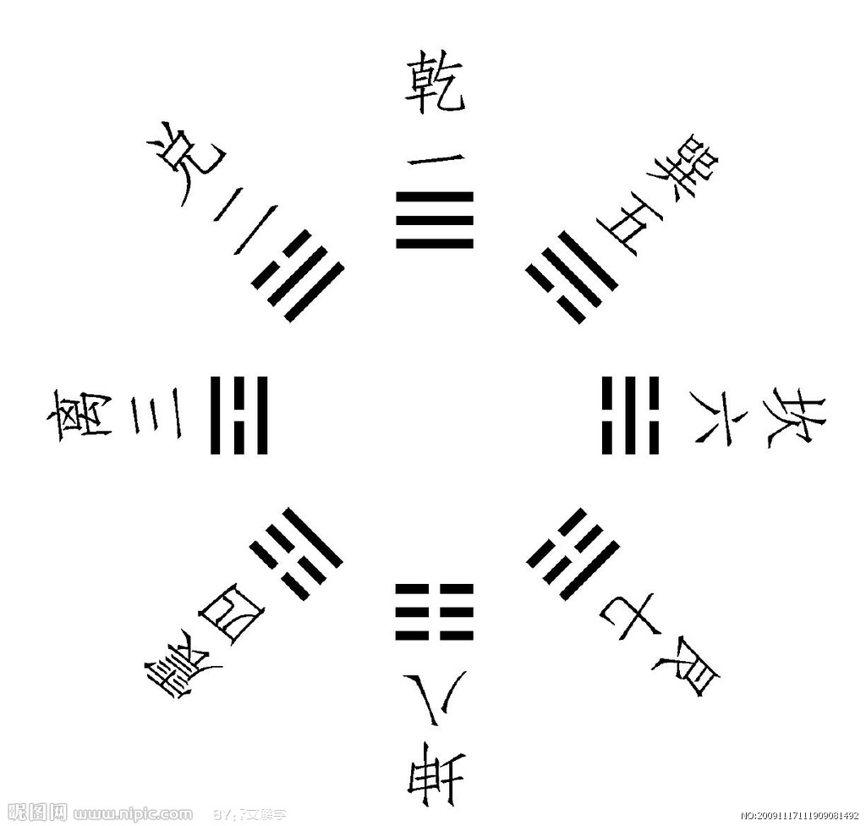

4. 伏羲——>洛神——> 宓妃——>甄宓
Ode to the Goddess of River Luo

5. Ten Legendary Kings
Name | Dates | Known for
Fushi | 3000 B.C | fire, hunting, trigrams, domestication of animals
Shen Nung | 2737–2598 B.C. | agriculture, medicine
Yen Di | brief rule | overthrown by his brother, Huang Di
Huang Di (Yellow Emperor) | 2697–2598 B.C. | dams, compass, calendar, coins
Yao Ti (Divine Yao) | 2357–2255 B.C. | astronomy, canal building
Shun | 2317–2208 B.C. | dams
Yu the Great | 2205–2197 B.C. | mapping, flood control, founder of the legendary Xia Dynasty, 2005–1520 , which has not yet been verified. B.C.

6. 洪水传说 （Water War）：共工，颛顼（或祝融）
In the war, The mighty Gong was defeated, his army dead or dispersed. Humiliated, Gong fled to the west until he reached the Buzhow Mountain（不周山）. In his rage, he hit his head into the peak of the mountain. His blow sent the sharp mountain peak flying upward, punching a huge hole in the sky. The dome of heaven cracked into a thousand fissures surrounding the gaping hole. At the same time, the force of Gong’s blow split open the crust of the earth. Exploding mountains threw out hot rocks to fire the land. Liquid fire oozed from every crevice, and smoke belched from the cracked ground. While the unsteady earth rocked and shaked, forest fires raged, and mountain lakes burst their containing walls, sending more flood to the villages below.

7. Key words: 共工，不周山
唤起工农千百万， 同心干， 不周山下红旗乱。——毛泽东《渔家傲·第一次反围剿》
《不周山》（后改为《补天》），见鲁迅《故事新编》

8．女娲补天 (Nuwa Repairs the Sky)

9. Key words: 女娲 五色石
“Long ago, when the goddess Nu-wa was repairing the sky, she melted down a great quantity of rock and, on the Incredible Crags of the Great Fable Mountains, moulded the amalagam into thirty –six thousand, five hundred and one large building blocks, each measuring seventy-two feet by a hundred and forty-four feet square. She used thirty-six thousand five hundred of these blocks in the course of her building operations, leaving a single odd block unused, which lay, all on its own, at the foot of Greensickness Peak in the aforementioned mountain.”
“Now this block of stone, having undergone the melting and moulding of a goddess, possessed magic powers. It could move about at will and could grow or shrink to any size it wanted. Observing that all the other blocks had been used for celestial repairs and that it was the only one to have been rejected as unworthy, it became filled with shame and resentment and passed its days in sorrow and lamentation.”
——From Chapter I, The Story of the Stone,trans. by David Hawkes
- 地陷东南
Long, long ago the world was tilted downwards towards the south-east; and in that lower- lying south-easterly part of the earth there is a city called Soochow; and in Soochow teh district around the Chang-men gate is reckoned one of the two or three wealthiest and most fashioable quarters in the world of men.
——From Chapter I, The Story of the Stone,trans. by David Hawkes
11. 大禹治水 (Yu Rebuilds the Earth)
Yu is the first to pass on his status as ruler to his descendants and thus create a dynasty. And this is the end of the mythical age and the beginning of dynasties ruled by ruling family.

- 夸父逐日（Kuafu Chases the Sun）
Quetion: Can you give the possible reasons why Kuafu run the marathon? Is Kuafu a hero or a fool? Have you heard a similar story in the Western literature?

- 刑天
Xingtian fought against [Huang] Di. Di cut off his head, and the head was buried in the Changyang Mountains. But Xingtian, with his breasts as eyes, and his navel as mouth, continued to fight with his spear and shield.

14. Jinwei, who was drowned in the violent sea,
Carries twigs to fill it by degree.
Xingtian, who was beheaded by the god,
Protests by waving his huge shield and rod.
Without life or death, they are free from care;
Now that they are dead, they never show despair.
Although their firm resolve has never pined,
Where and when will be the chance they find?
——陶渊明《读山海经》之十
- 精卫填海 (Jingwei fills the East Sea)
16. 张悦然《誓鸟》
- 后羿射日（The Grand Archer Yi）
18. 后羿与嫦娥 （Yi and Chang’E）
- 鲁迅《奔月》（The Flight to the Moon）
- 叶兆言《后羿》

Homework
1. Translate this paragraph into English.
往古之时，四极废，九州裂。天不兼覆，地不周载。火爁焱而不灭，水浩洋而不息。猛兽食颛民，鸷鹰攫老弱。于是，女娲炼五色石，以补苍天；断鳌足，以立四极；杀黑龙，以济冀州；积芦灰，以止淫水。——刘安《淮南子》

2. Refer to different English translations of the following poem in Hongloumeng and try to contribute your own translation.
无才可去补苍天，枉入红尘若许年。此系身前身后事，倩谁记去作奇传？

3. Read “Mending Heaven”, “The Flight to the Moon” and “Curbing the Flood” in Luxun’s Old Tales Retold translated by Yang Xianyi and Gladys Yang. Before reading these English versions, read the Chinese original first.

