Associate Professor, Dr. GU Mingyi
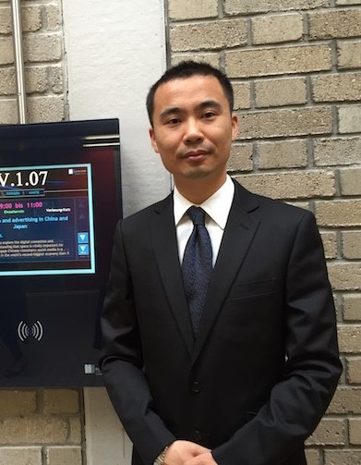
Mentor of Graduate in M.A., Mentor of MBA
Advertising Department, School of Journalism & Communication,
Shanghai International Studies University
University Studies and Researches
Ph.D in Marketing Science (May 2007), Tongji University, Shanghai
Post-Doctor in Advertising (Aug 2010 - Apr 2013), Fudan University
Researching Area
Consumer Oriented Advertising Theories and Models: (e.g. Involvement & Engagement)
International Advertising: Global Consumer Culture and Advertising Response Process: Attitude, Intention of Information and Persuasion
Classic Advertising Theories and Digital Advertising Theories
Invited Lectures
Asian Social Media and Advertising (M.A.) COMM 3012, Alpen-Adria University/ University of Klagenfurt, APR 2015
Social Media Role of Port Enterprises in China (Investigation lectures), Invited Program Instructor, Antwerp Management School, University of Antwerp, Spring 2014
Advertising Response Effect of out-of-home advertising and engagement in China, International Conference Of Research In Advertising (ICORIA), Ljubljana, Slovenia, Jul 2016
- China Advertising Academy Association Scholar
- AAA American Advertising Association & EAA European Advertising Association
- Jury member of 2015 IAI International Advertising Award, China

