上海外国语大学 2020 –2021学年第一学期
期末考试试卷

课程名称 中国文化概要
课程编号 TRL3140.1402
任课教师 江帆
姓名 蔡哲予 学号 0203701049
姓名 李扬 学号0203701047
姓名 江穹 学号0203701044
姓名 卢楚怡 学号0203701090
姓名张汶珊 学号0203701091
姓名 冯仁人 学号0203701085
Please write an essay about 500-800 words in English, explaining a cultural phenomenon in China. A comparative perspective is encouraged.

The rise of public baths in the Song Dynasty

Introduction
Many people know Wan Anshi because of his political achievements and poems. However, few people know that he hated bathing. Luckily, his anecdotes were recorded in many novels. One being Meng Xi Bi Tan, an ancient encyclopedia written in the Song Dynasty. But why? Why his bath hating stories could be included in these famous novels and are still being told today? Well, maybe it reflects the importance of bath in China whether it is in the ancient days or today.

1 The reasons for the boom of public baths
1.1 Social cause: citizen consciousness
Liangshuifa, the twice-taxation system, introduced in the late Tang Dynasty transformed the relationship between landlords and peasants from lords and slaves to contract partners. By the Song Dynasty, land could be traded legally, creating, despite the wealth gap, a win-win situation where landlords could assuredly acquire more land while peasants’ social status would also be improved, for, in theory, they could accumulate a fortune and become landlords themselves. This improvement aroused citizen consciousness. Simply put, the disadvantaged peasants began treating themselves as independent, free individuals and caring more about individual well-being, including hygiene and entertainment.

1.2 Economic cause: prosperity
Though the Song Dynasty was weak in defence, it was extremely affluent. Entrepreneurship was widely pursued and commodity economy and commerce were well-established, which generated demands in reality. An increasing number of people traveling for commercial, personal, and official purposes needed a place to rest and bathe during their journeys, so public baths met their requirements. From the few in transportation hubs and commercial centers, they then scattered across the country and became more convenient with better service. Gradually all citizens started visiting them.

A minor cause was urbanization. Large numbers of peasants who were then free from a life-long bond moved from villages to cities. Influenced by the bathing culture in cities, they visited public baths frequently, which in return popularizing this culture.

1.3 Cultural cause
Moreover, based on the adoption and popularity of “Xi San” bath ceremony, we can infer that the rise of public baths in the Song Dynasty is probably due to the civilians’ worship for the ritual of the royal families and nobles. This point is our group’s conjecture.

At first, “Xi San” bath ceremony was initiated by Li Longji, Emperor Xuanzong of Tang. He held a fragrant bath ceremony for his grandson, Li Yu, on the third day after his birth. Since then, "Xi San" bath ceremony became the ritual of the royal families of the Tang Dynasty. Whenever a royal baby was born, a bath ceremony would be held on the third day after his or her birth. This ritual was retained among royal families of the Tang Dynasty, and gradually gained popularity among the ordinary people.

Thanks to the economic boom in the Song Dynasty, people’s standards of living were raised. Common people were eager to enjoy bathing like the royal families and nobles, thus promoting the rise of public baths.

2 Structure and features
A public bath contains public bathrooms, individual bathtubs, hand washing barrels, and heaters for wraps.
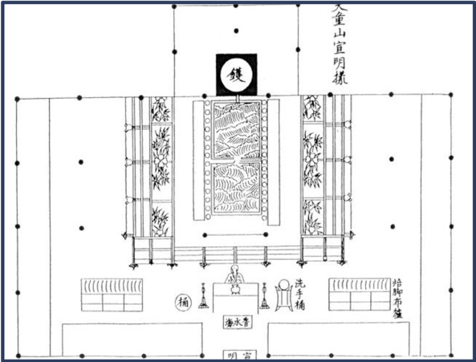
The public baths in Song Dynasty had some features.
First, the bathroom would provide both cold baths and hot baths for customers, just like what we do in modern times. Cold baths might suit people who wanted to strengthen their bodies, while hot baths served for foreigners who could not get used to cold baths. There were two ways for a public bathroom to provide hot water. It would either burn coals and wood to heat water, or channel water from hot springs.

Second, public baths would provide face washing service in the morning.

Third, businessmen would hang a pot as an advertisement in front of the door to show here was a public bathroom. It was similar to what the barber’s does today.

Last, sometimes many public baths would densely scatter along the lane in big cities including two capital cities of Lin’an and Dongjing. Some lanes were even called “public bath lane” because they were jammed with too many public baths. Furthermore, ancient people could find some small public baths in remote areas as well, so they availed themselves of cleaning facilities and relaxed during a long journey. This also showed how prosperous the business industry was in the Song Dynasty.

3 Relevant services
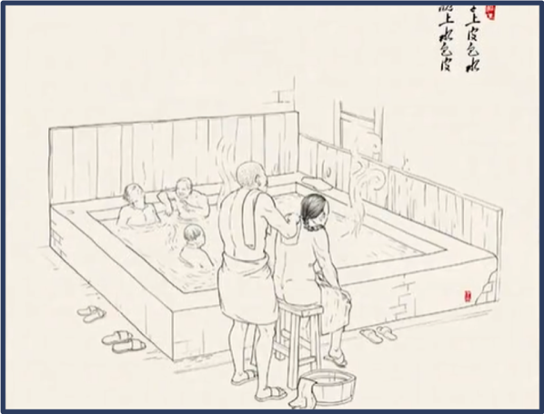
The rise of the public baths also boosted the evolution of services in public bathrooms. From this picture we can see a worker using a bath towel to help his customer wash his body. Actually, it can also be found in many poems. For example, Su Shi once wrote a poem describing his experience in a public bath. The poem indicated that there was a skilled worker who provided Su shi with washing service. Su Shi might have felt a little bit painful in this process, so he said “please easy up, please easy up. There is not much dirt on my body”.

Besides, the major bathing supplies changed over time. During the Qin and Han dynasties, people bathed in water saved after cleaning the rice, for it could stop itching and reduce inflammation.

During the Wei and Jin dynasties. A natural material was found to have a cleansing effect. It was called “Zaojiao” or “Zaojia” in Chinese, being the “Chinese honey locust fruit”. It produced bubbles when being soaked in water and could remove sweat.

Some time afterward, people made “bathing beans”, “Zaodou” by mixing ground pig’s pancreas, soybean powder and spice. Bathing beans could both clean and moisturize the skin. Due to the short supply of pig’s pancreas, bathing beans were not produced on large scale. Only rich families and noble families had the privilege to use them.

In the Song Dynasty, people started to make “soap balls”. So why do we call soap “Feizao” instead of “thin soap” (“fei” literally means “fat” and “zao” means “soap” in Chinese.)? Here is the story. The Chinese honey locust fruit mentioned above as “Zaojia” was found only alongside the Yellow River. However, there were no Chinese honey locust trees in the Yangtze River region. Another kind of tree was found to have the same effect. People called it “Feizaoguo” or “Feizaozi”, meaning “fat Chinese locust fruit”, for the fruits were much larger. That is the origin of the name “Feizao”.

People in the Song Dynasty cooked and crushed the “Feizaozi”, and then blended them with spice and shaped them into balls akin to oranges. The soap balls could be used both for bathing and doing laundry. The book Anecdotes of Martial Arts Circles (Wu Lin Jiu Shi), written by Zhou Mi, recorded that soap balls were so popular in cities that flagship stores had already been established to sell soap balls in Lin’an city, capital of the South Song Dynasty. Later, flower juice was added to the soap balls to give them a strong aroma. Thus, the soap ball industry thrived in the Song Dynasty with the rise of public baths.

4 A ramification
An attempted murder happened in a public bath in 1119 A.D., recorded by Yi Jian Zhi. A regional official came to the capital, waiting to be tested. Craving for the post, he got up super early the next day and entered a public bath for a rest. After scanning his obese figure and luxurious clothes, three servants in the bath plotted to murder him. They fastened the official with a belt and dragged him into the inner room of the bath, intending to kill him after dark. However, after a while, the belt loosened, so the official quickly escaped the bath and shouted out “help” on the street. Luckily, the chief executive of the capital heard it and stopped by the bath. After hearing the whole story, the executive decided to raid the bath. Finally, he found three corpses that were all killed the night before. It turned out that this bath was simply run by brigands, and the servants not only murdered people for wealth, but also sold their flesh to the market. Hence, this was a consequential illegal industry during the rise of public baths.

5 Conclusion
The emerging citizen consciousness, the booming economy, and the civilians' worship for the ritual of the royal families and nobles altogether contributed to the rise of public baths over time, with the purposes of bathing widened and the bathing places expanded. Meanwhile, relevant services and industries also thrived as bathing became a fashion and culture, despite some dire consequences.

